**CHAPTER 4**

**Methodology**

This chapter covers the Requirement Analysis, Requirement Documentation, Design of the Software, Design of the System, System Processes, Development and Testing, Description of the System, Implementation Plan, and Implementation Results.

**Requirements Analysis**

This sections presents the Economic Feasibility, Requirements Modelling and the Risk Assessment/Analysis of the project.

***System Requirements***

This section presents the system requirements and modelling of the <name of system>. <Note: This a process is used to determine the needs and expectations of your project>.

***Input***

<Present the input requirements in bullets. System inputs represent data that enter the system. It could be manual or automatic>

* The user must have correct login credentials in order to use the system.
* The user needs to input the number of hours worked and the number of absences of the employee.
* The user need to upload an image of the affected skin.

***Process***

<Present the process requirements in bullets. System processes are logical rules applied to transform data into meaningful information>

* The system must authenticate the login credential provided.
* The system will compute for the salary of the employee.
* The uploaded image will undergo Convolutional Neural Network for the computation of its weights.
* The result of computation will be compared to the trained datasets.

***Output***

<Present the output requirements in bullets. System outputs represent information produced by the system. It may be electronic or printed>

* The system will generate the monthly salary of all employees.
* The application must be able to display the type of skin rash uploaded.

***Performance***

<Discuss the performance requirement. Performance refers to the following system characteristics: Speed, volume, capacity, availability, and reliability>

* The system must be operational seven days a week.
* Response time must not exceed 5 seconds.
* The system must be capable of supporting 30 online users simultaneously.
* The must be able to prepare the monthly salary of employees a day after the end of the month.

***Security and Control***

<Discuss the control requirements. Security and control requirements looks at hardware, software, and controls that safeguard and protect the system and its data from threats both external and internal>

* An employee record must be added, changed, or deleted only by a member of the human resources department.
* The system must maintain separate levels of security for users and the system administrator.

***Data and Process Modelling***

***Context Diagram***

The context diagram shown in Figure xx presents the basic overview of the whole system or process being analyzed or modeled. <discuss briefly>

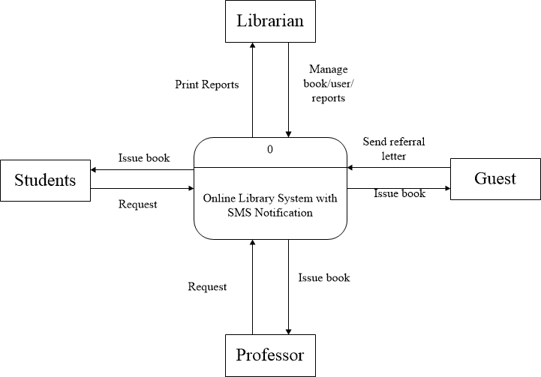

Figure xx. The Context Diagram

***Data Flow Diagram***

The dataflow diagram provides a more detailed breakout of pieces of the Context Diagram into sub-processes. Figure xx-xx are the Data Flow Diagrams – Level 1and Level 2 respectively.

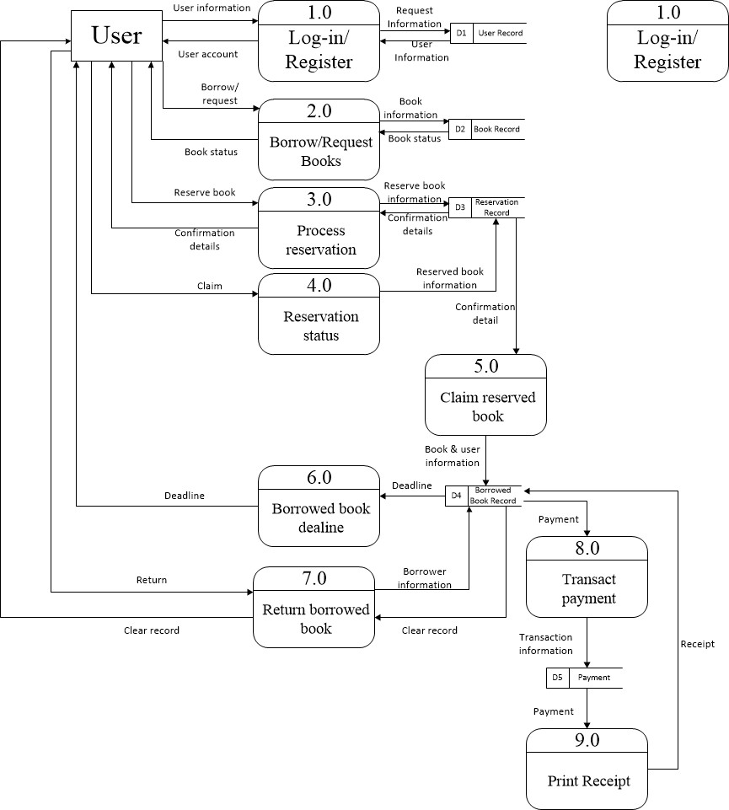

Figure xx. Data Flow Diagram (Level 1)

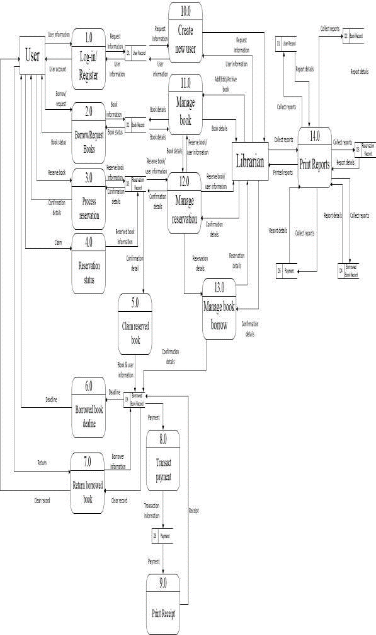

Figure xx. Data Flow Diagram (Level 2)

***System Flowchart***

Flowcharts are used in analyzing, designing, documenting or managing a process or program in various fields. Its representation illustrates a solution model to a given problem. Shown in Figures xx-xx are the system flowcharts for each type of user.

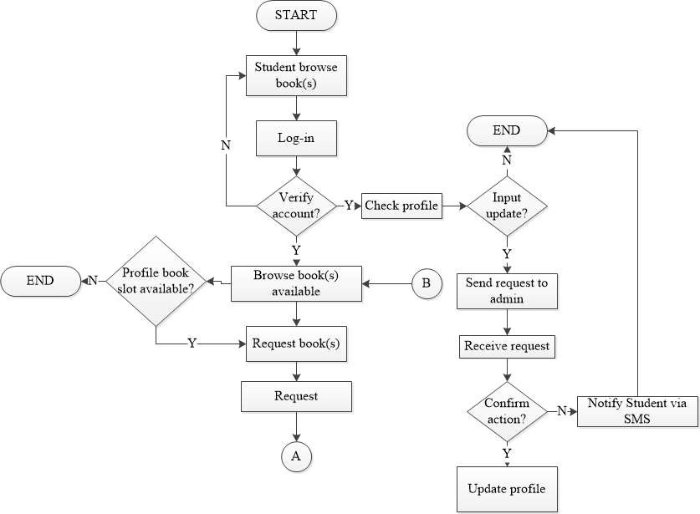

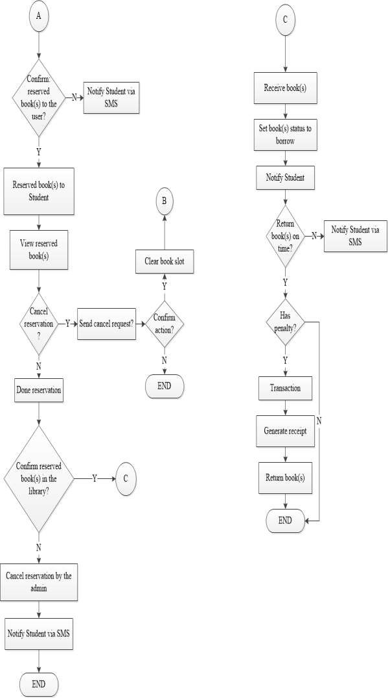

Figure xx. System Flowchart - Students

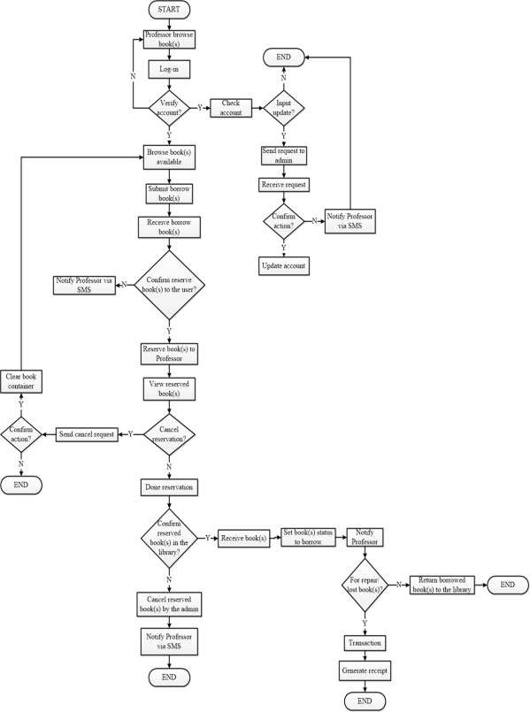

Figure xx. System Flow Chart - Professor

***Object Modelling***

***Use Case***

Figure xx-xx are the Use Case Models for the proposed system. These are representations of a user's interaction with the system that shows the relationship between the user and the different use cases in which the user is involved.

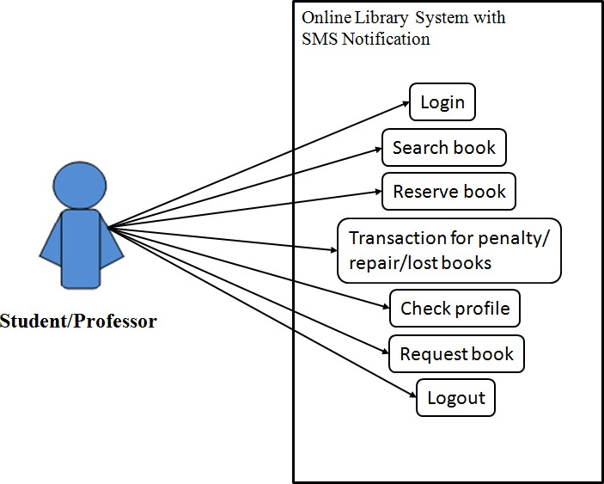

Figure xx.The System’s Use Case Diagram for Student

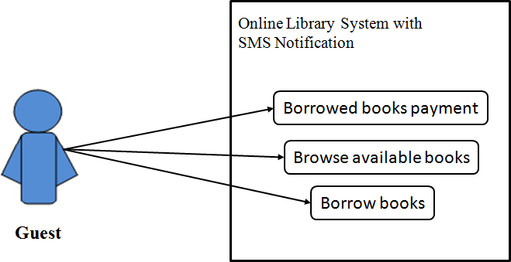

Figure xx.The System’s Use Case Diagram for Guest

***Risk Assessment/Analysis***

Table xx identifies and analyzes all of the potential risks and issues that are detrimental to the implementation of <name of system> The steps to prevent or minimize the occurrence of the identified risks are also presented.

Table xx. Risk Assessment

|  |  |  |  |
| --- | --- | --- | --- |
| **Risk Description** | **Effect** | **Risk Grading**  **(Low, Medium, High)** | **Recovery Measure** |
| Malware infection | Malfunction of system  Data loss | High | Install anti-virus software |
| No internet connection | Inaccessible application/website | Low | Subscribe to another ISP |

**Design of the Software**

This section discusses the design and implementation of the data structures and algorithms used in the software. It presents the data design that produced the detailed data model of database such as the Database schema in Figure xx and the data dictionary in Figures xx-xx.

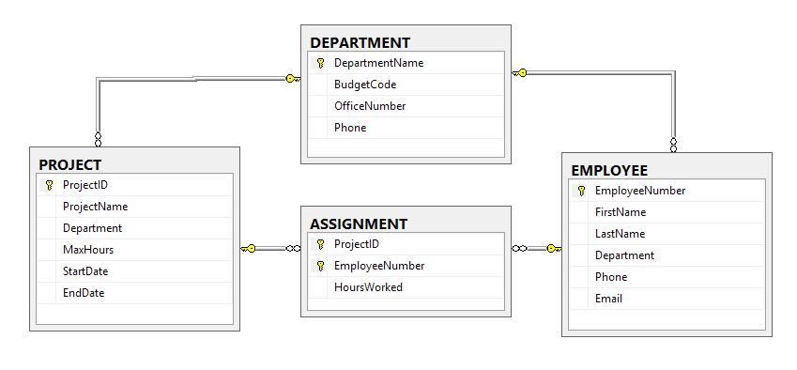

Figure xx. Database schema of the developed system

*<NOTE:insert Data Dictionary for EACH TABLE in your database>*

# Table 9. Data Dictionary – tbl_accountupdate

|  |  |  |
| --- | --- | --- |
| **Column** | **Type** | **Comment** |
| **Id** | int(11) *Auto Increment* | Unique ID of the current table |
| **student_id** | varchar(255) | ID number of the person which is displayed on a person's school ID |
| **Name** | varchar(255) | Fullname of the person |
| **Privilege** | varchar(255) | User level of the user |
| **Bday** | varchar(255) | Date of birth of the person |
| **Email** | varchar(255) | Email address of the person |
| **Address** | varchar(255) | Current home address of the person |
| **Number** | varchar(255) | Active mobile number of the person which will be used by the system for notification features |
| **Photo** | varchar(255) | Actual image of the person for additional identification |
| **Newemail** | varchar(255) | An Updated email address of the person |
| **Newaddress** | varchar(255) | An updated home address of the person |
| **Newnumber** | varchar(255) | A new mobile number of the person |
| **Newphoto** | varchar(255) | An updated image of the person |

**Design of the System**

The developed system is an online web-based system that runs on web platforms using different browsers. Figures xx to xx are the screenshots taken from the developed system.

***Interface Design***

**Login**. Figure xx provides the form used to enter login credentials. This authenticates the users of the system.

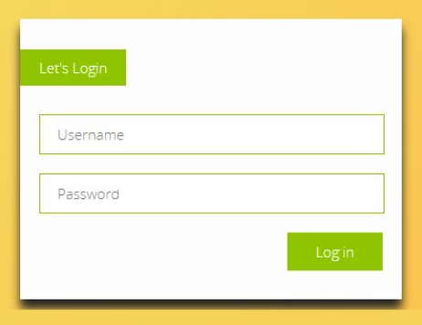

*Figure xx. Login Form*

*<NOTE: include all interfaces, forms and reports>*

**System Process**

*<Discuss then present the figure>*

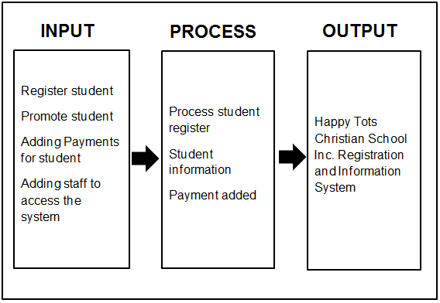

Figure xx. The IPO System Process

**Development and Testing**

***Software Development***

**<***Concrete explanation on how the system was developed and tested. Researcher may pattern their discussion in any SDLC (discuss each phase) then present the figure>*

The system development process is anchored to the System Development Life Cycle (SDLC) waterfall model as shown in Figure xx. The first phase is analysis, where the developer carefully studied the nature of the proposed system…... An interview and an onsite visit were conducted to ensure that the real scenario would be incorporated into the proposed system. Consultation with the target client was also done to make the system more realistic and address their needs more effectively.

***Hardware Specification***

Table xx presents the minimum hardware specifications in developing the <name of system>

|  |  |
| --- | --- |
| **Hardware** | **Description/Specification** |
|  |  |
|  |  |

***Software Specification***

Shown in Table xx is the software specifications for the development of<name of system>.

|  |
| --- |
| **Software** |
|  |
|  |

***Testing***

After development, testing of the developed <name of system> was done. Unit testing was conducted to ensure that the system functions as designed. Compatibility testing was also done to ensure that the web-based system can run using different browsers such as Google Chrome…. in a windows-based computer. The system was not tested to run in other operating systems (however, if you have done it, then include in your discussion).

System testing was also conducted with the target clients as the evaluators. The members of the Panel Evaluation Committee also evaluated the project. Feedback during testing was utilized to help enhance the developed system. The instrument used in the evaluation was adapted from the ISO 25010 to assess the system’s functionality, efficiency, usability, maintenance, reliability, portability, security, and compatibility.

**Description of the System**

The developed system creates a user-friendly design for all types of users. The front end of the system utilizes PHP and other frameworks for web programming <you can discuss here further other technologies, programming tools, or scripting languages>. The developed system is web-responsive and data-driven powered by MySQL for database functionality.

<Discuss further the features of your system>

**Implementation Plan**

Figure xx presents the implementation plan of the project. This covers from the planning phase to deployment and evaluation of the project.

**Phase**

**Activities**

Figure xx. Implementation Plan

**Implementation Result**

<Discuss in narrative form the result of your implementation plan>

<Then present the result of your evaluation in tabular form then discuss>

Table xx is the result of the evaluation using the ISO 25010. Frequency, mean and modal interpretation are used in the treatment of data using the corresponding Likert Scale provided below.

Table xx. User Evaluation of <name of system>

|  |  |  |  |  |  |  |  |
| --- | --- | --- | --- | --- | --- | --- | --- |
| **Criteria** | **5** | **4** | **3** | **2** | **1** | **Mean** | **Interpretation** |
| **Functionality** |  |  |  |  |  |  |  |
| The system performs the tasks required. |  |  |  |  |  |  |  |
| The result is as expected. |  |  |  |  |  |  |  |
| The system interacts with another system. |  |  |  |  |  |  |  |
| The system prevents unauthorized access. |  |  |  |  |  |  |  |
| **Reliability** |  |  |  |  |  |  |  |
| Most of the faults in the system have been eliminated over time. |  |  |  |  |  |  |  |
| The system is capable of handling errors. |  |  |  |  |  |  |  |
| The system notifies the user about wrong data entry. |  |  |  |  |  |  |  |
| The software resumes working and restores lost data after a failure. |  |  |  |  |  |  |  |
| **Usability** |  |  |  |  |  |  |  |
| The user comprehends how to use the system easily. |  |  |  |  |  |  |  |
| The user learns to use the system easily. |  |  |  |  |  |  |  |
| The user utilizes the system without much effort. |  |  |  |  |  |  |  |
| The system’s interface looks good. |  |  |  |  |  |  |  |
| **Efficiency** |  |  |  |  |  |  |  |
| The system responds quickly to the user. |  |  |  |  |  |  |  |
| The system’s execution time is appropriate. |  |  |  |  |  |  |  |
| The software utilizes resources efficiently. |  |  |  |  |  |  |  |
| **Maintainability** |  |  |  |  |  |  |  |
| The system faults can be easily diagnosed. |  |  |  |  |  |  |  |
| The system continues functioning when changes are made. |  |  |  |  |  |  |  |
| The software can be tested easily. |  |  |  |  |  |  |  |
| **Portability** |  |  |  |  |  |  |  |
| The system can be moved to other environments. |  |  |  |  |  |  |  |
| The software can be installed easily. *(for administrator)* |  |  |  |  |  |  |  |
| The software can replace easily other software. *(for administrator)* |  |  |  |  |  |  |  |
| **Security** |  |  |  |  |  |  |  |
| The software ensures confidentiality of data |  |  |  |  |  |  |  |
| The software prevents unauthorized access and modification to computer programs and/or data |  |  |  |  |  |  |  |
| The software requires authentication of users |  |  |  |  |  |  |  |
| A system log is maintained. |  |  |  |  |  |  |  |
| **Compatibility** |  |  |  |  |  |  |  |
| The software performs its required functions efficiently while sharing a common environment and resources without negatively impacting any other product/s. |  |  |  |  |  |  |  |
| The software allows two or more systems, products, or components to exchange and use the information. |  |  |  |  |  |  |  |

<Discuss the result of your evaluation.>

**CHAPTER V**

**RECOMMENDATIONS**

<Discuss recommendations. Recommendations may include based on the results of system implementation and evaluation. You may also include other recommendations for the improvement of your system>

**Bibliography (Note: APA format)**

**Appendices**

Relevant Source Code (*insert at least one application*)

Database Connection

Add

Save

Edit / Update

Delete (if there are any)

Evaluation Instrument

Sample input/output/Reports

Users Guide

Pictures showcasing the data gatherings, investigation done

One-Page Curriculum Vitae per team member